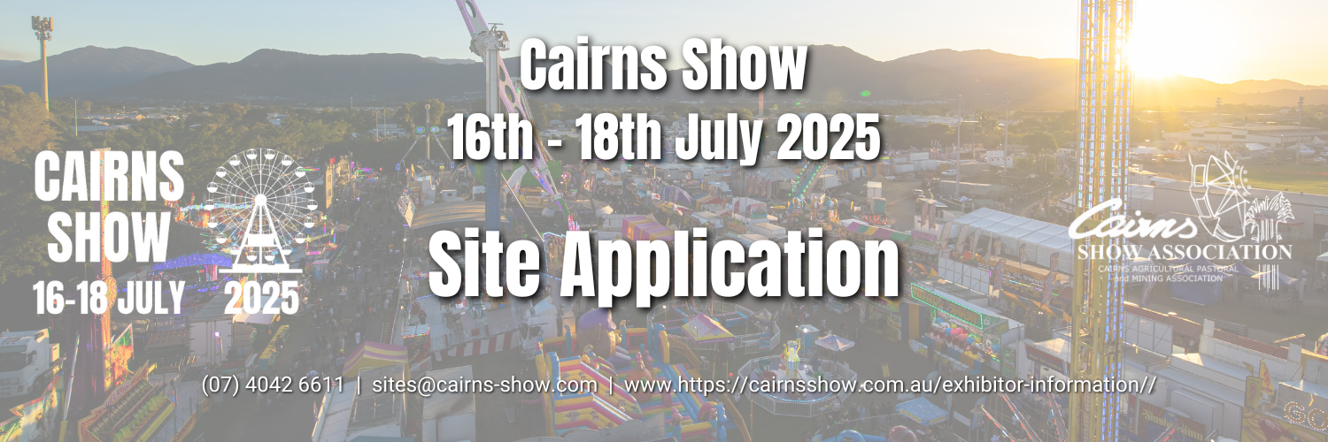

*Please print clearly and complete all sections accurately.*

|  |  |  |  |  |  |  |  |  |  |  |  |  |  |  |  |  |  |  |  |  |  |  |  |  |  |  |
| --- | --- | --- | --- | --- | --- | --- | --- | --- | --- | --- | --- | --- | --- | --- | --- | --- | --- | --- | --- | --- | --- | --- | --- | --- | --- | --- |
| Company or Organisation Name: | | | | | |  | | | | | | | | | | | | | | | | | | | | |
|  | | | | | | | | | | | | | | | | | | | | | | | | | | |
| Are you a returning Cairns Show Exhibitor? | | | | | | Yes | |  | No | | | |  | | | |  | | | | | | | | | |
|  | | | | | | | | | | | | | | | | | | | | | | | | | | |
| Contact Person: | | | |  | | | | | | | | | | | | ABN: | | |  | | | | | | | |
| Postal Address: | | | |  | | | | | | | | | | | | | | | | | Post Code: | | | |  | |
| Phone: | |  | | | | | | | | | Mobile: | | | | | | |  | | | | | | | | |
| Email: | |  | | | | | | | | | | | | | | | | | | | | | | | | |
| Website: | |  | | | | | | | | | | | | | | | | | | | | | | | | |
| Purpose of Site: | | | |  | | | | | | | | | | | | | | | | | | | | | | |
| Items to be Sold: | | | |  | | | | | | | | | | | | | | | | | | | | | | |
|  | | | | | | | | | | | | | | | | | | | | | | | | | | |
| Type of Site: | | | Garages, Machinery, Pools, Boats, Camper Vans, Cars, etc. | | | | |  | | Balloons, Hats, Jewellery, Novelties, Showbags, Tattoos, Marketing, etc. | | | | | | | | | | | |  | | Food | |  |
|  | | | $ 115.50 p/m | | | | |  | | $ 231.00 p/m | | | | | | | | | | | |  | | $ 262.50 p/m | |  |
|  | | | | | | | | | | | | | | | | | | | | | | | | | | |
| Public Liability: | | | | Policy #: | | | |  | | | | | | | Name of Insurer: | | | | | | | |  | | | |
| Indemnity Level: | | | | Minimum $20m: | | |  | | | | | | | | Date current to: | | | | | | | |  | | | |
| Power Required: | | | | *Please list ALL electrical appliances to be used & approx. amperage of each – all electrical appliances and cords must have current testing and tagging.* | | | | | | | | | | | | | | | | | | | | | | |
|  | | | | | | | | | | | | | | | | | | | | | | | | | | |
| Name of 2 authorised persons to collect passes (identification will be required at the time of collection): | | | | | | | | | | | | | | | | | | | | | | | | | | |
| 1. |  | | | | | | | | | | | 2. | |  | | | | | | | | | | | | |
| My employees, agents, and I shall observe and be bound by the Terms and Conditions as set out in the Exhibitor’s Manual for site space at the Cairns Show. These Terms and Conditions are hereby incorporated into the agreement as if the same were expressly set out at length. I have read and understood the Exhibitor’s Manual and the Terms and Conditions. Also available on our website – [www.cairnsshow.com.au](http://www.cairnsshow.com.au) | | | | | | | | | | | | | | | | | | | | | | | | | | |
| Signature of applicant: | | | | |  | | | | | | | | | | | | | | | Date: | | |  | | | |
|  | | | | |  | | | | | | | | | | | | | | |  | | |  | | | |

|  |  |  |  |  |  |  |
| --- | --- | --- | --- | --- | --- | --- |
| 1st Preference | 2nd Preference | | 3rd Preference | | | |
| _________ | _________ | | _________ | | | |
| Site # | Site # | | Site # | | | |
| Frontage: | Frontage: | | Frontage: | | | |
|  |  |  | |  |  | |
| Additional: | 1 Day Worker Pass | # | | $15.00/each | $ | |
|  | *Free Passes inc. in site fees – see manual* |  | |  |  | |
| Additional: | 1 Day Car Park Pass | # | | $18.00/each | $ | |
|  | *Please circle -*  *Wednesday, Thursday, Friday* |  | |  |  | |
|  |  | **Total Cost:** | | | |  |